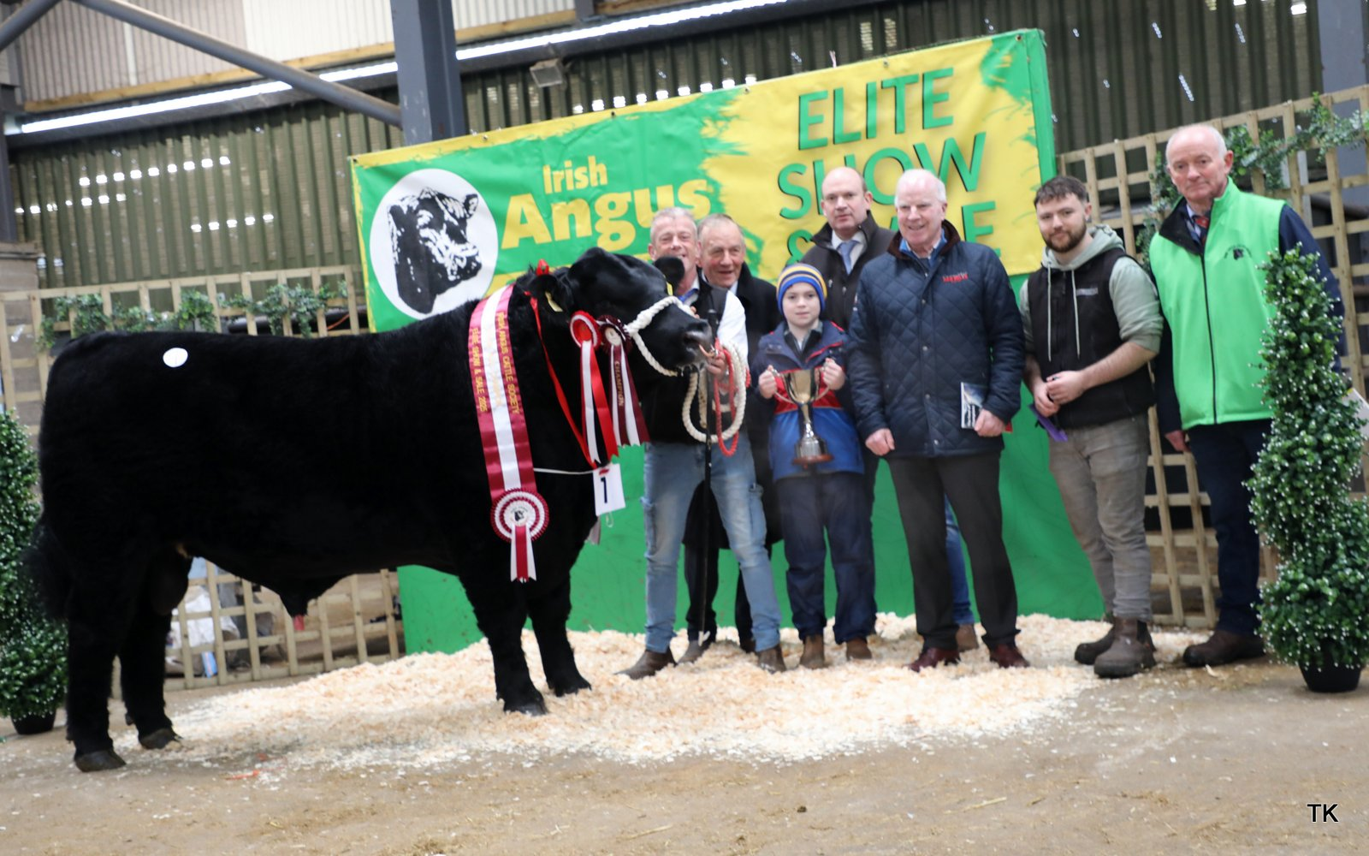
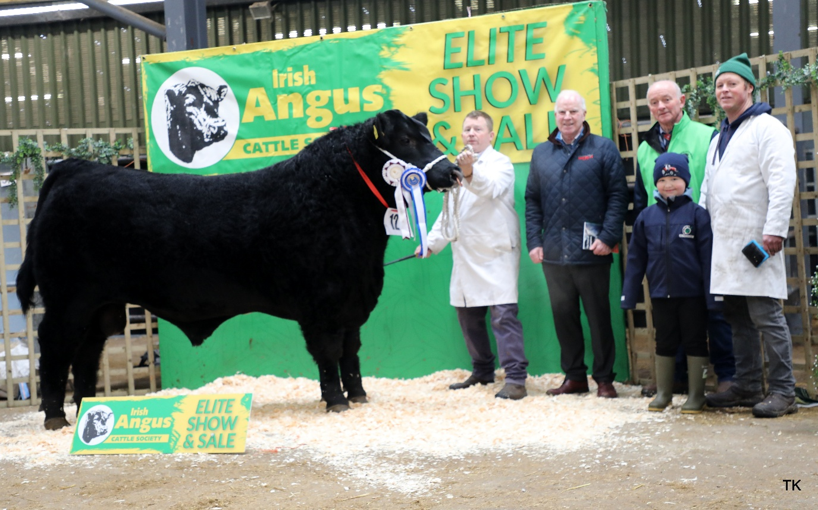
Reserve Senior Male Champion Molloy Alainn Sold €5,600 Breeder: Brian & Mary Faughnan, Clooncarne, Bornacoola, Co. Leitrim Niall Faughnan, Anthony Flaherty (Connolly Redmills), Gerard Kilgallon (President), Eoghan McLoughlin, Brian Faughnan

Senior Male Champion Steil Avatar Sold €7,600 Breeder: Cathal & J.J. McCormack, Steil, Tulsk, Castlerea, Co. Roscommon
Declan Fahy, Joe, Cathal & Caelan McCormack, Anthony Flaherty (Connollys Redmills), Jack Cronin, Gerard Kilgallon (President)
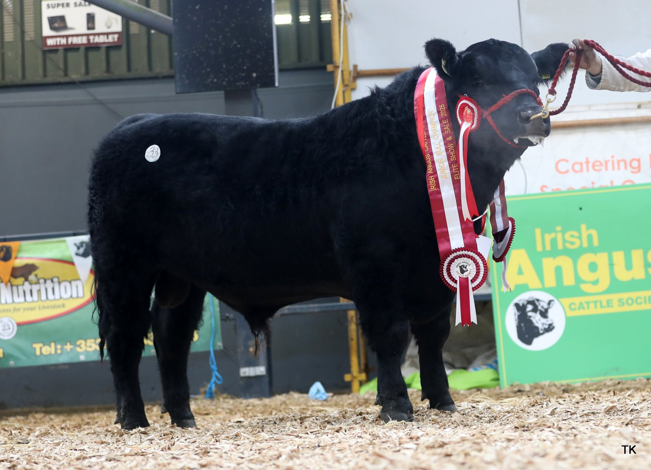

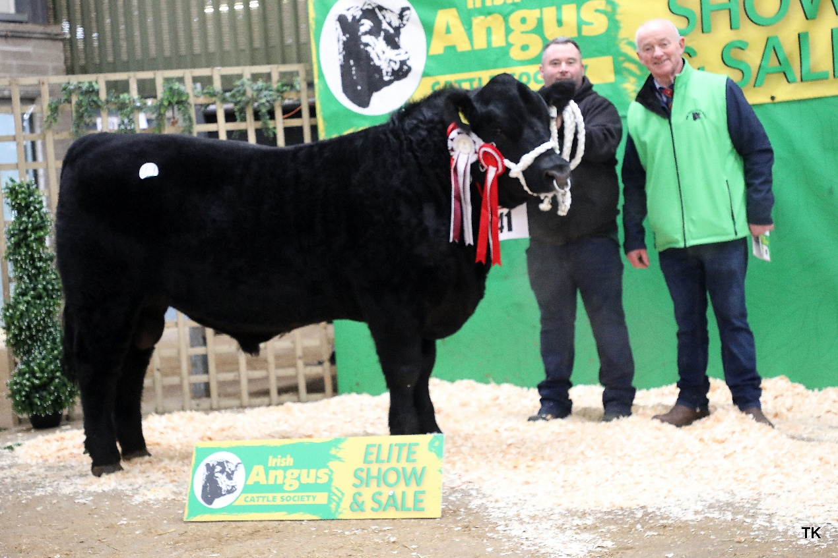
Junior Male Champion Driney Atomic Bomb Sold €8,000 Breeder: Gerard & Patrick Regan, Driney, Castlerea, Co. Roscommon

Reserve Junior Male Champion Charraigach Avicii Sold €4,300 Breeder: Martin Kerins, Carrigans Lr., Ballymote, Co. Sligo Ollie Kerins & Gerard Kilgallon (President)

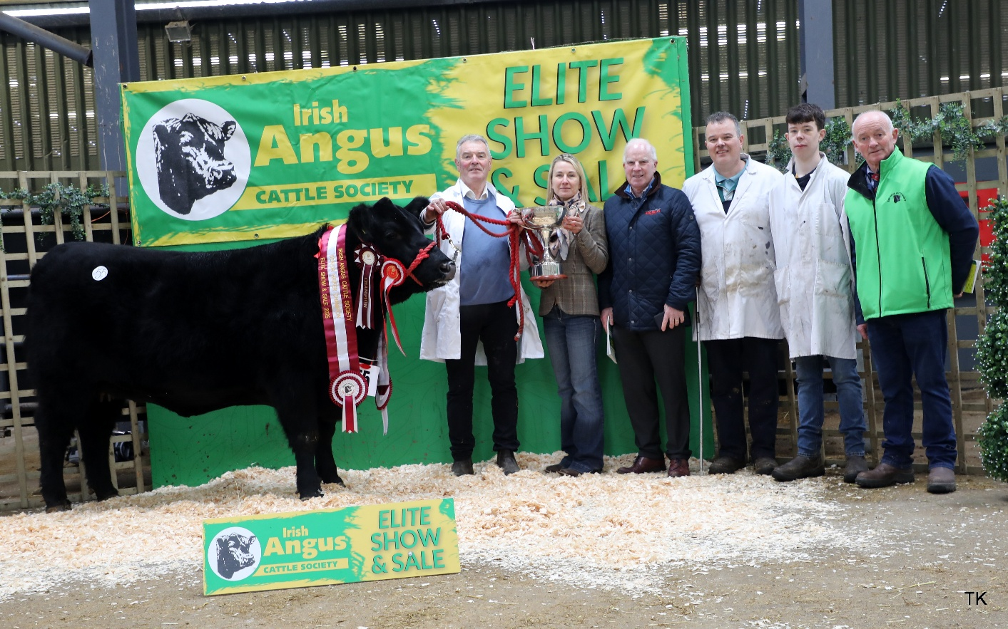

Senior Female Champion Loughlynn Wild Rose Sold €5,000 Breeder: Patrick Regan Jnr, Cloonmore, Ballyfarna, Claremorris, Co. Mayo Patrick Regan, Daniela Wintereder (Judge) Anthony Flaherty (Connollys Red Mills), Gerard & Patrick Regan, Gerard Kilgallon (President)

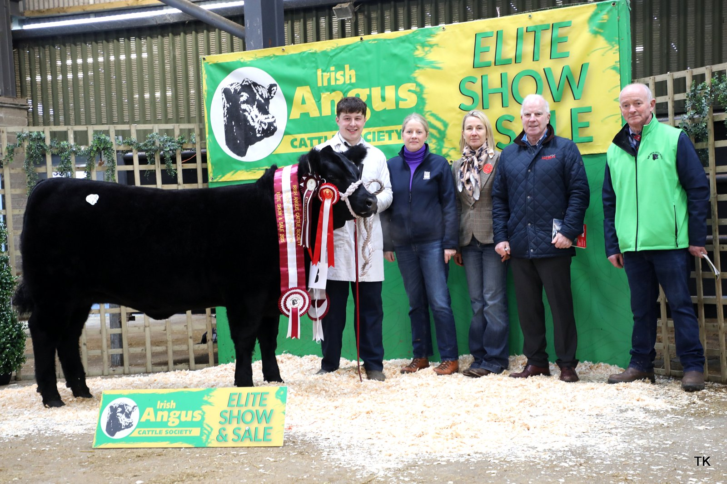

Junior Female Champion Millbawn Autumn Star Sold €9,000 Breeder: Amanda Bogan & Conor Craig, Coolarty, Edgeworthstown, Co. Longford Conor Craig, Amanda Bogan, Daniela Wintereder (Judge) Anthony Flaherty (Connollys Red Mills), Gerard Kilgallon (President)

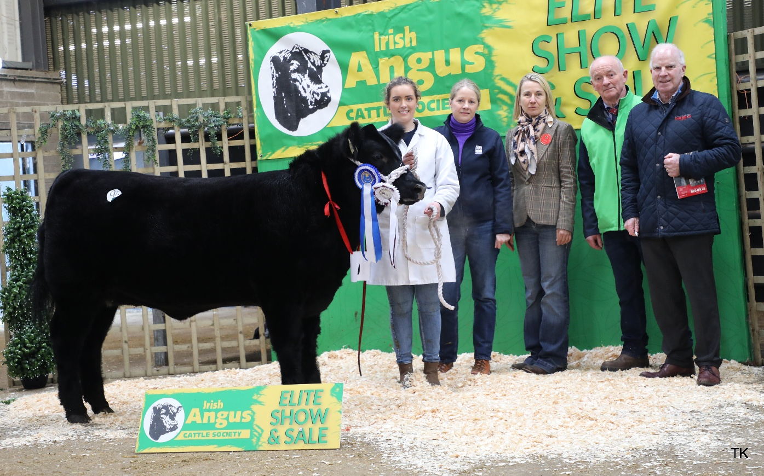
Reserve Junior Female Champion Millbawn Athena Breeder: Amanda Bogan & Conor Craig, Coolarty, Edgeworthstown, Co. Longford Cailin Keavney, Amanda Bogan, Daniela Wintereder (Judge), Gerard Kilgallon (President), Anthony Flaherty (Connollys Red Mills)
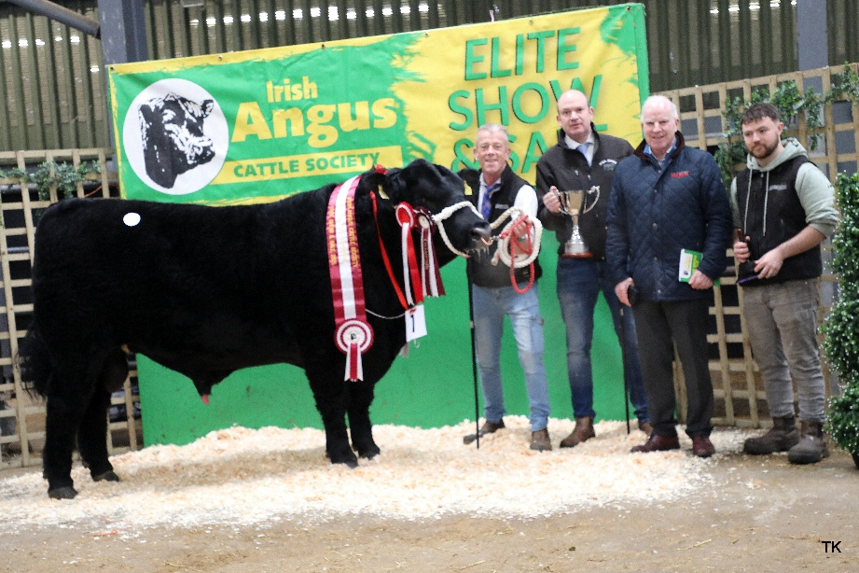
Class 1 Winner Steil Avatar Sold €7,600 Breeder: Cathal & J.J. McCormack, Steil, Tulsk, Castlerea, Co. Roscommon Declan Fahy, Cathal McCormack, Anthony Flaherty (Connollys Redmills), Jack Cronin

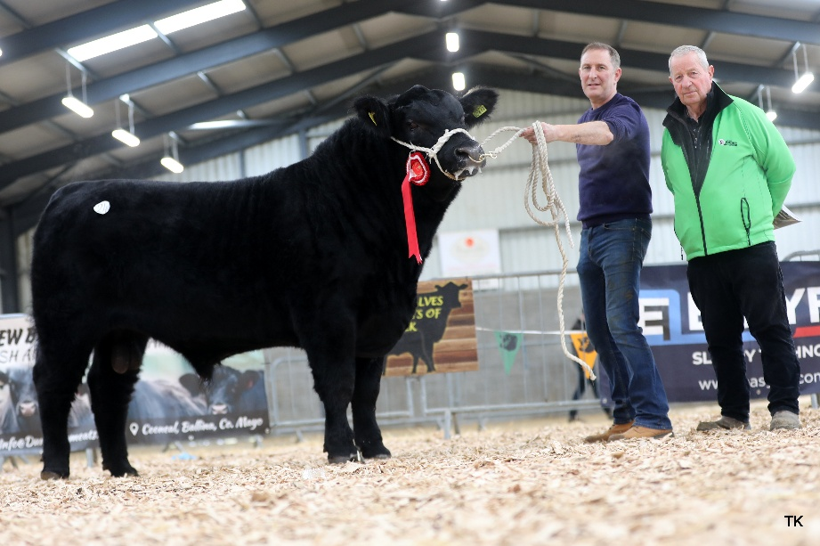

Class 2 Winner Drumcarbin Accelerator Sold €8,000 Breeder: Shane McKiernan, Drumcrow, Corlismore, Ballinagh, Co. Cavan

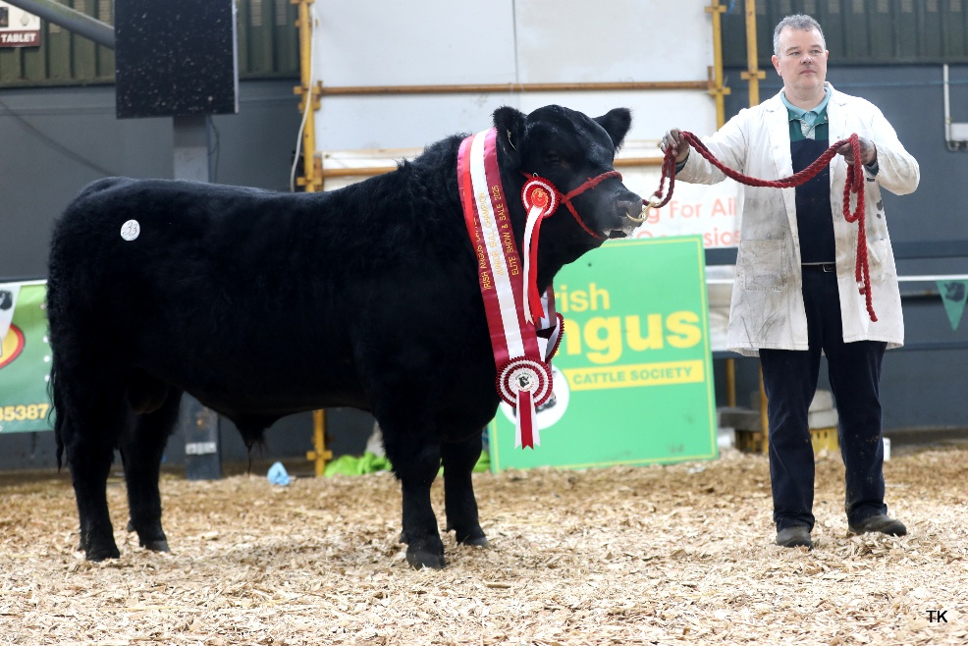

Class 3 Winner Driney Atomic Bomb Sold €8.000 Breeder: Gerard & Patrick Regan, Driney, Loughlynn, Castlerea, Co. Roscommon

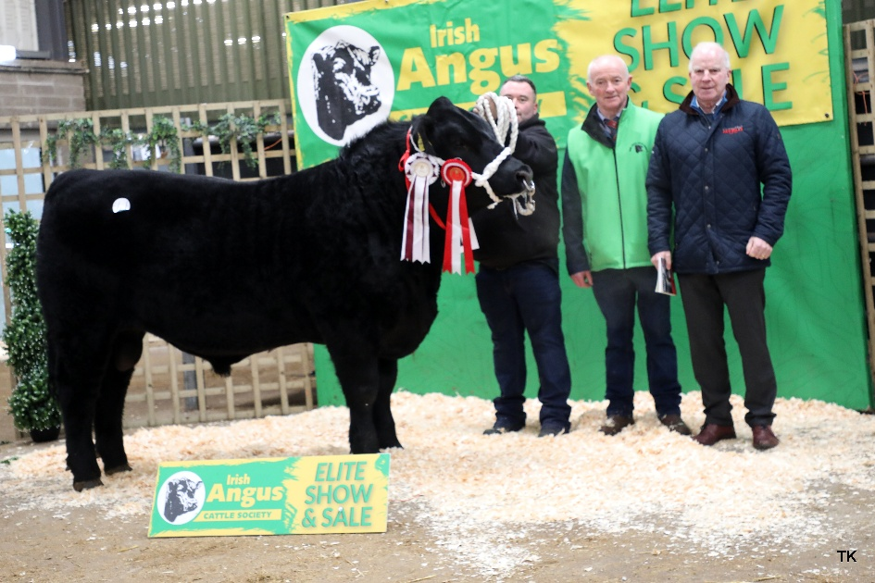

Class 4 Winner Charraigach Avicii Sold €4,300 Breeder: Martin Kerins, Carrigans Lr., Ballymote, Co. Sligo Ollie Kerins & Gerard Kilgallon (President), Anthony Flaherty (Connollys Redmills)

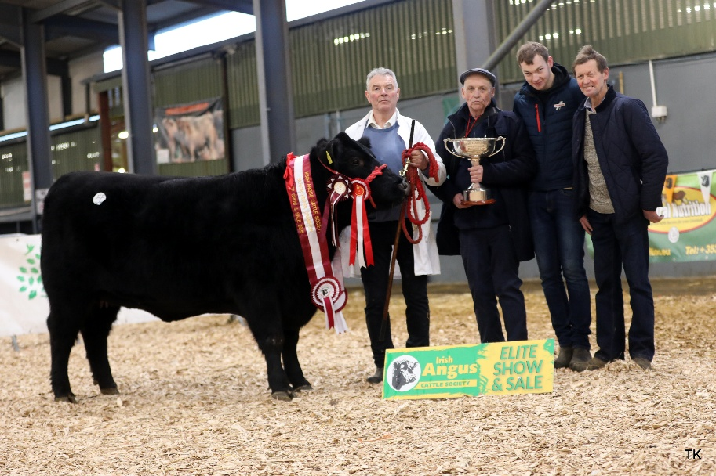
Class 5 Winner Loughlynn Wild Rose Sold €5,000 Breeder: Patrick Regan Jnr, Cloonmore, Ballyfarna, Claremorris, Co. Mayo

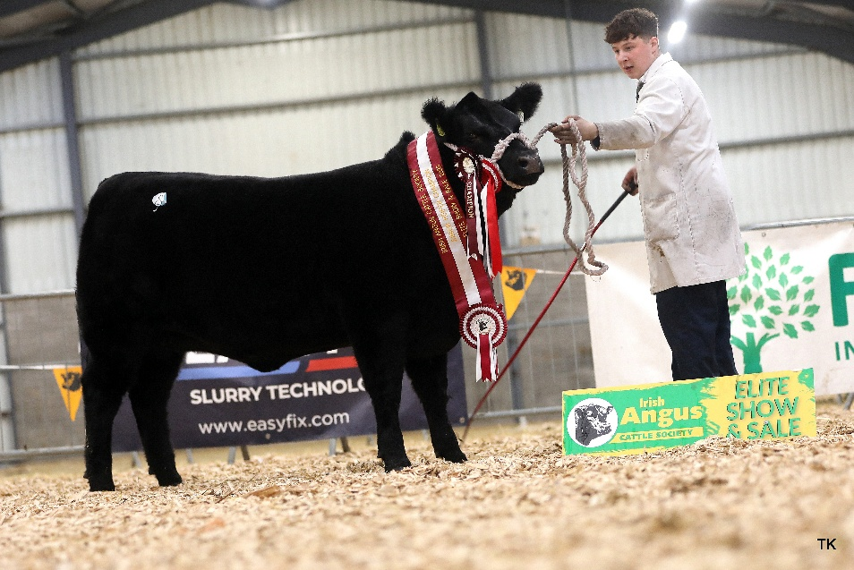

Class 8 Winner Millbawn Autumn Star Sold €9,000 Breeder: Amanda Bogan & Conor Craig, Coolarty, Edgeworthstown, Co. Longford Conor Craig

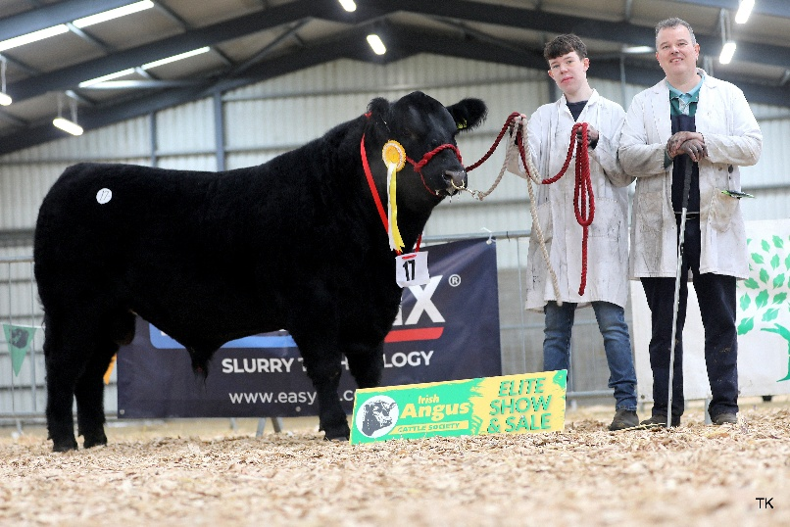

Driney Ace of Spades Sold €9,200 Breeder: Gerard & Patrick Regan, Driney, Castlerea, Co. Roscommon

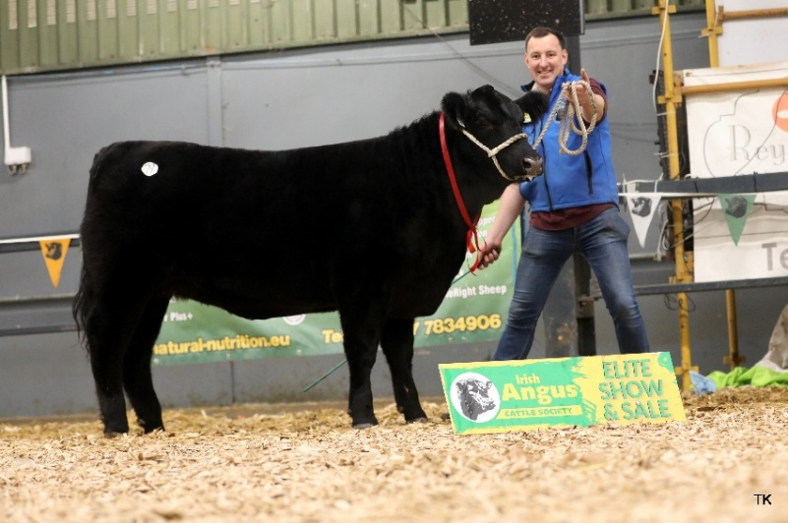
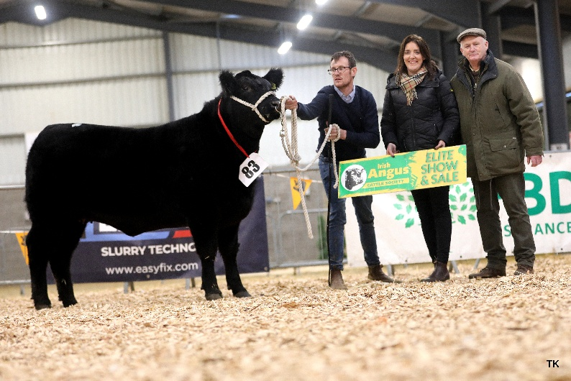

Laheens Ariana Sold: €9,000 Breeder: Cormac Duignan, Laheens, Eslin Bridge, Carrick-on-Shannon Co. Leitrim
Loughglass Athena Sold: €9,000 Breeder: Breeder: Noel & Lisa Dowd, Skehard, Creggs, Co. Galway Derek Maxwell, Lisa & Noel Dowd

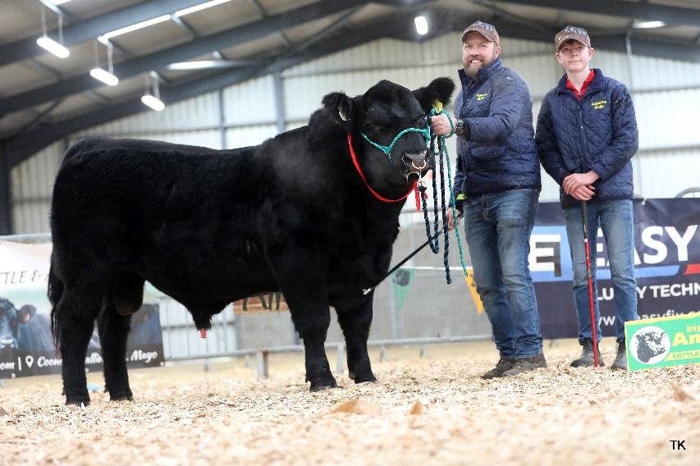
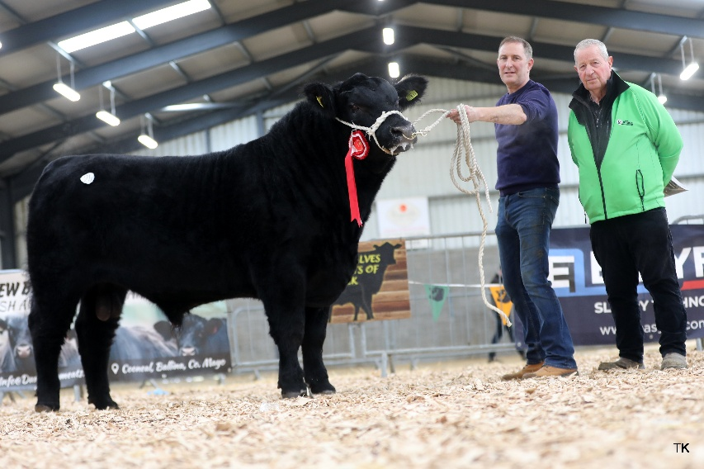

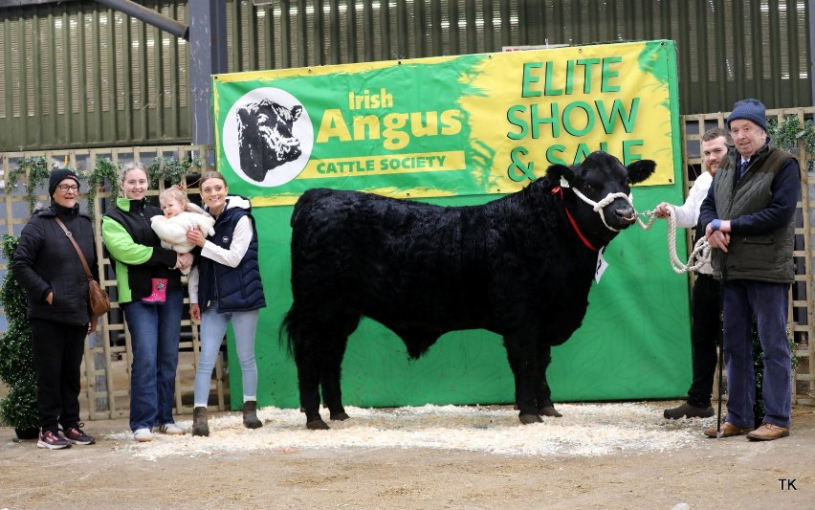
Drumcarbin Accelator 448 Sold €8,000 Breeder: Shane McKiernan, Drumcrow, Corlismore Ballinagh, Co. Cavan Shane McKiernan & Joe Moran (Purchaser)
Carrigroe Alister Sold €8,200 Breeder: J & F Appelbe, Carrigroe, Clonakilty, Co. Cork John & Eric Appelbe
Clooneybeirne Albert Sold: €7,600 Breeder: Martin O’Connor, Clooneybeirne, Strokestown, Co. Roscommon Carmel O’Connor, Caitriona Devine, Craoi Shannon, Katie & Johsua Cronin, Martin O’Connor
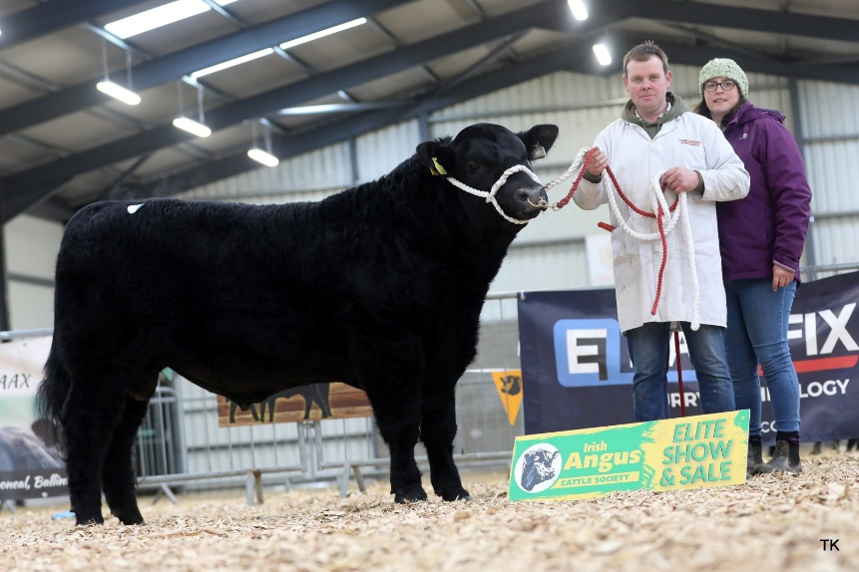
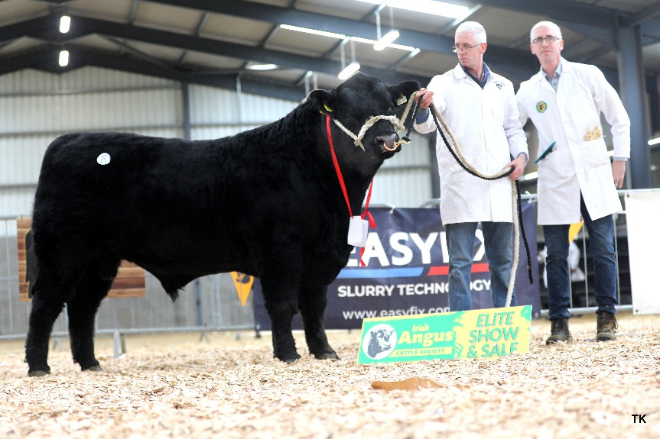
Corlismore Achiever Sold €7,000 Breeder: Sean & Gary McKiernan, Corlismore House, Corlismore, Co. Cavan
Bunlahy Apache Sold €7,400. Breeder: Aiden & David Reynolds, Bunlahy, Ballinalee, Co. Longford

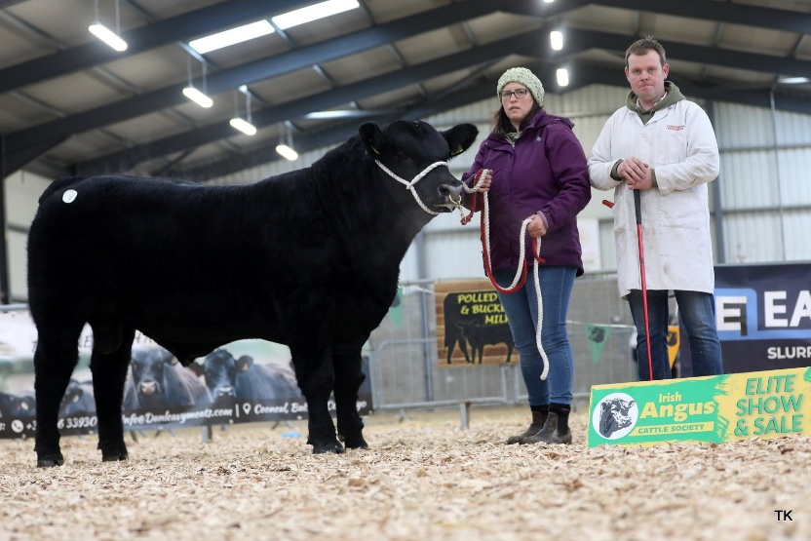
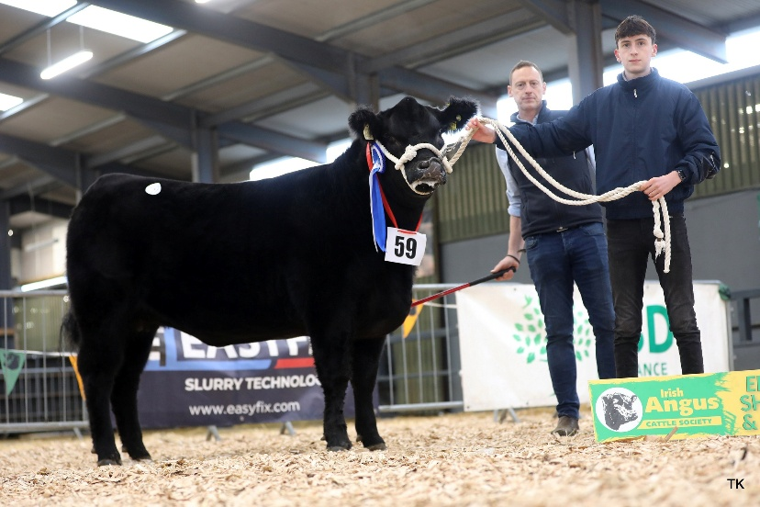

Caulry A023 Ellen Erica Sold €7,000 Breeder: T & A Fitzgerald, Glebe House, Mount Temple Moate, Co. Westmeath
Corlismore Aston Martin Sold €6,800 Breeder: Sean & Gary McKiernan, Corlismore House, Corlismore, Co. Cavan

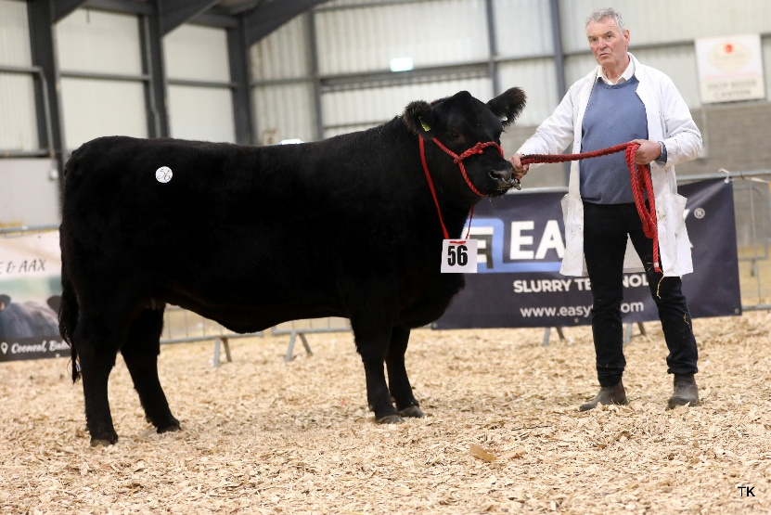
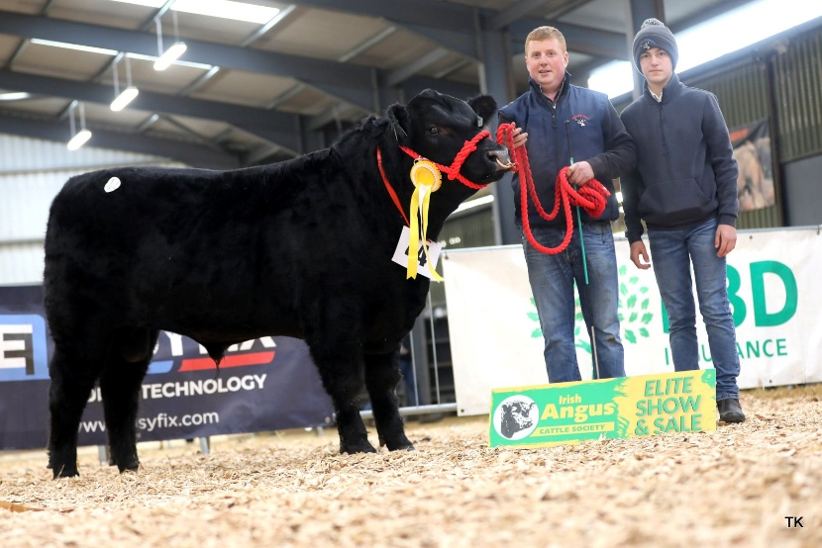
Ryans Victorious Sold €4,800 Breeder: Ger Ryan, Castleblagh Ballyhooly Co Cork Ger Kieran & Mathew Ryan,

Ryans Victorious Sold €4,800 Breeder: Ger Ryan, Castleblagh Ballyhooly Co Cork Ger Kieran & Mathew Ryan,

Ryans Victorious Sold €4,800 Breeder: Ger Ryan, Castleblagh Ballyhooly Co Cork Ger Kieran & Mathew Ryan,

Carrowboy Alberto Sold €6,600 Breeder: Alan Gibbons, Caggle, Strokestown, Co. Roscommon

Loughlynn Wonder Girl Sold €6,400 Breeder: Patrick Regan Jnr, Cloonmore, Ballyfarna, Claremorris, Co. Mayo

